DEPARTMENT OF COMPUTER STUDIES

**(Applications Development and Emerging Technologies)**

**PRE-SUMMATIVE ASSESSMENT**

**1**

**PHP OUTPUT AND VARIABLE FAMILARIZATION**

**Student Name / Group**

**Name: Tria, Patrick Andrew**

**Name** **Role**

**Members (if Group):**

**Section: 1A TN31**

**Professor: Mr. Abraham Magpantay**

1. **PROGRAM OUTCOME/S (PO) ADDRESSED BY THE LABORATORY EXERCISE**
   * Design, implement and evaluate computer-based systems or applications to meet desired needs and requirements.

**II. COURSE LEARNING OUTCOME/S (CLO) ADDRESSED BY THE LABORATORY EXERCISE**

* + Understand and apply best practices and standards in the development of website.

**III. INTENDED LEARNING OUTCOME/S (ILO) OF THE LABORATORY EXERCISE**

At the end of this exercise, students must be able to:

* + - Familiarize various Web Architecture, tools that used in PHP
    - The basic understanding before using PHP
    - Familiarize in environment of web developing
    - Use of comments, variables and Echo / Print

**IV. BACKGROUND INFORMATION**

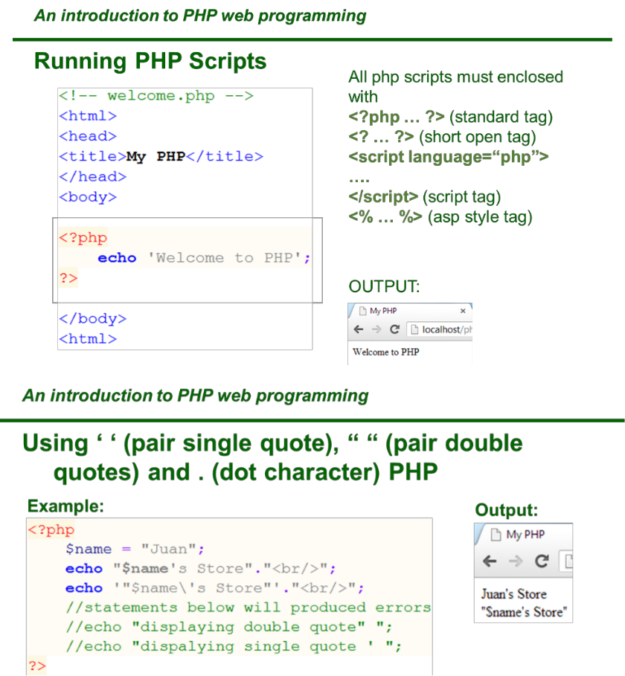

|  |  |
| --- | --- |
| **Applications Development and Emerging Technologies** | **Page 2 of** |
| **11** |  |

**Example**

Write some text to the output:

<?php

echo "Hello world!";

?>

**Definition and Usage**

The echo() function outputs one or more strings.

**Note:** The echo() function is not actually a function, so you are not required touse parentheses with it. However, if you want to pass more than one parameter to echo(), using parentheses will generate a parse error.

**Tip:** The echo() function is slightly faster than print().

**Tip:** The echo() function also has a shortcut syntax. Prior to PHP 5.4.0, thissyntax only works with the short_open_tag configuration setting enabled.

Syntax

echo(*strings*)

Parameter Values

Parameter strings

Description

Required. One or more strings to be sent to the output

Technical Details

Return Value: No value is returned

PHP Version: 4+

More Examples

Write the value of the string variable ($str) to the output:

<?php

$str = "Hello world!";

echo $str;

?>

|  |  |
| --- | --- |
| **Applications Development and Emerging Technologies** | **Page 3 of** |
| **11** |  |

Join two string variables together:

<?php

$str1="Hello world!";

$str2="What a nice day!";

echo $str1 . " " . $str2;

?>

Write the value of an array to the output:

<?php

$age=array("Peter"=>"35");

echo "Peter is " . $age['Peter'] . " years old."; ?>

Write some text to the output:

<?php

echo "This text

spans multiple

lines.";

?>

How to use multiple parameters:

<?php

echo 'This ','string ','was ','made ','with multiple parameters.'; ?>

Difference of single and double quotes. Single quotes will print the variable name, not the value:

<?php

$color = "red";

echo "Roses are $color";

echo "<br>";

echo 'Roses are $color';

?>

|  |  |
| --- | --- |
| **Applications Development and Emerging Technologies** | **Page 4 of** |
| **11** |  |

**PHP Variables**

**Creating (Declaring) PHP Variables**

In PHP, a variable starts with the $ sign, followed by the name of the variable:

**Example**

<?php

$txt = "Hello world!";

$x = 5;

$y = 10.5;

?>

After the execution of the statements above, the variable $ txt will hold the value Hello world!, the variable $x will hold the value 5, and the variable $y will hold the value 10.5.

**Note:** When you assign a text value to a variable, put quotes around the value.

**Note:** Unlike other programming languages, PHP has no command for declaringa variable. It is created the moment you first assign a value to it.

Think of variables as containers for storing data.

**PHP Variables**

A variable can have a short name (like x and y) or a more descriptive name (age, carname, total_volume).

Rules for PHP variables:

* A variable starts with the $ sign, followed by the name of the variable
* A variable name must start with a letter or the underscore character
* A variable name cannot start with a number
* A variable name can only contain alpha-numeric characters and underscores (A-z, 0-9, and _ )
* Variable names are case-sensitive ($age and $AGE are two different variables)

|  |  |
| --- | --- |
| **Applications Development and Emerging Technologies** | **Page 5 of** |
| **11** |  |

Remember that PHP variable names are case-sensitive!

**Output Variables**

The PHP echo statement is often used to output data to the screen.

The following example will show how to output text and a variable:

**Example**

<?php

$txt = "W3Schools.com";

echo "I love $txt!";

?>

The following example will output the sum of two variables:

**Example**

<?php

$x = 5;

$y = 4;

echo $x + $y;

?>

**V. GRADING SYSTEM / RUBRIC (please see separate sheet)**

|  |  |
| --- | --- |
| **Applications Development and Emerging Technologies** | **Page 6 of** |
| **11** |  |

**VI.** **LABORATORY ACTIVITY**

1. The student will create their own portfolio using HTML and CSS with the integration of PHP Scripts
2. Refer to the samples below



|  |  |
| --- | --- |
| **Applications Development and Emerging Technologies** | **Page 7 of** |
| **11** |  |



1. Use variable for the information provided in the webpage. Example:

//variable for your firstname $firstname = ‘Christopher’;

|  |  |
| --- | --- |
| **Applications Development and Emerging Technologies** | **Page 8 of** |
| **11** |  |

**VII. QUESTION AND ANSWER**

1. **What program you use to create your webpage?**

The programs that I used are XAMPP, in order to access PHP and a web browser, Mozilla Firefox to see its output.

1. **What kind of variables that you use in the webpage?**

I used strings and arrays as the variable type in my webpage. Strings for variables like name, phone, email, address, city, state and etc. and array for the contents of my educational background, qualifications and skills.

1. **Is it important to study html and css before using PHP?**

Yes, because in order to integrate HTML and CSS which will be the front-end of your program, making it appealing in the eyes of your customers, you would need sufficient knowledge of the language.While PHP will serve as the back-end of it. Integrating those together would require lots of practice and knowledge to how they each work together.

1. **What are the different ways to produce an output in PHP?**

In PHP, there are two basic ways to get output, it is through **echo** and **print** statements.

**VIII. REFERENCES**

1. <https://www.w3schools.com/php/func_string_echo.asp>
2. <https://www.w3schools.com/css/>
3. <https://www.w3schools.com/html/>
4. <https://www.w3schools.com/php/php_variables.asp>
5. <https://dribbble.com/shots/5295835-Free-Resume-Template-For-Developers-With-Portfolio>
6. <https://www.intelivate.com/career-strategy/simple-resume-model-career-portfolio-example>

***Snip and paste your source codes here. Snip it directly from the IDE so that colors of the codes are preserved for readability. Include additional pages if necessary.***

|  |  |
| --- | --- |
| **Applications Development and Emerging Technologies** | **Page 9 of** |
| **11** |  |

**Note: The following rubrics/metrics will be used to grade students’ output.**

|  |  |  |  |  |
| --- | --- | --- | --- | --- |
| **Program (100** | **(Excellent)** | **(Good)** | **(Fair)** | **(Poor)** |
| **pts.)** |  |  |  |  |
| **Program** | Program executes | Program executes | Program executes | Program does not |
| **execution (20pts)** | correctly with no | with less than 3 | with more than 3 | execute **(10-** |
|  | syntax or runtime | errors **(15-17pts)** | errors **(12-14pts)** | **11pts)** |
|  | errors **(18-20pts)** |  |  |  |
| **Correct output** | Program displays | Output has minor | Output has | Output is incorrect |
| **(20pts)** | correct output | errors **(15-17pts)** | multiple errors | **(10-11pts)** |
|  | with no errors |  | **(12-14pts)** |  |
|  | **(18-20pts)** |  |  |  |
| **Design of output** | Program displays | Program displays | Program does not | Output is poorly |
| **(10pts)** | more than | minimally | display the | designed **(5pts)** |
|  | expected **(10pts)** | expected output | required output |  |
|  |  | **(8-9pts)** | (**6-7pts)** |  |
| **Design of logic** | Program is | Program has | Program has | Program is |
| **(20pts)** | logically well | slight logic errors | significant logic | incorrect **(10-** |
|  | designed **(18-** | that do no | errors **(3-5pts)** | **11pts)** |
|  | **20pts)** | significantly |  |  |
|  |  | affect the results |  |  |
|  |  | **(15-17pts)** |  |  |
| **Standards** | Program code is | Few inappropriate | Several | Program is poorly |
| **(20pts)** | stylistically well | design choices | inappropriate | written **(10-11pts)** |
|  | designed **(18-** | (i.e. poor variable | design choices |  |
|  | **20pts)** | names, improper | (i.e. poor variable |  |
|  |  | indentation) **(15-** | names, improper |  |
|  |  | **17pts)** | indentation) **(12-** |  |
|  |  |  | **14pts)** |  |
| **Delivery** | The program was | The program was | The program was | The program was |
| **(10pts)** | delivered on time. | delivered a day | delivered two | delivered more |
|  | **(10pts)** | after the deadline. | days after the | than two days |
|  |  | **(8-9pts)** | deadline. **(6-7pts)** | after the deadline. |
|  |  |  |  | **(5pts)** |

|  |  |
| --- | --- |
| **Applications Development and Emerging Technologies** | **Page 10 of** |